**GIT Remoting**

**Objective:** Pushing source code into GITHUB & collaborate team members.

SECTION-1 (Pushing assignments to remote repository) - Steps to follow:

**39. Create a GitHub account if you do not have already.**

GitHub Account link: <https://github.com/vedantmathankar>

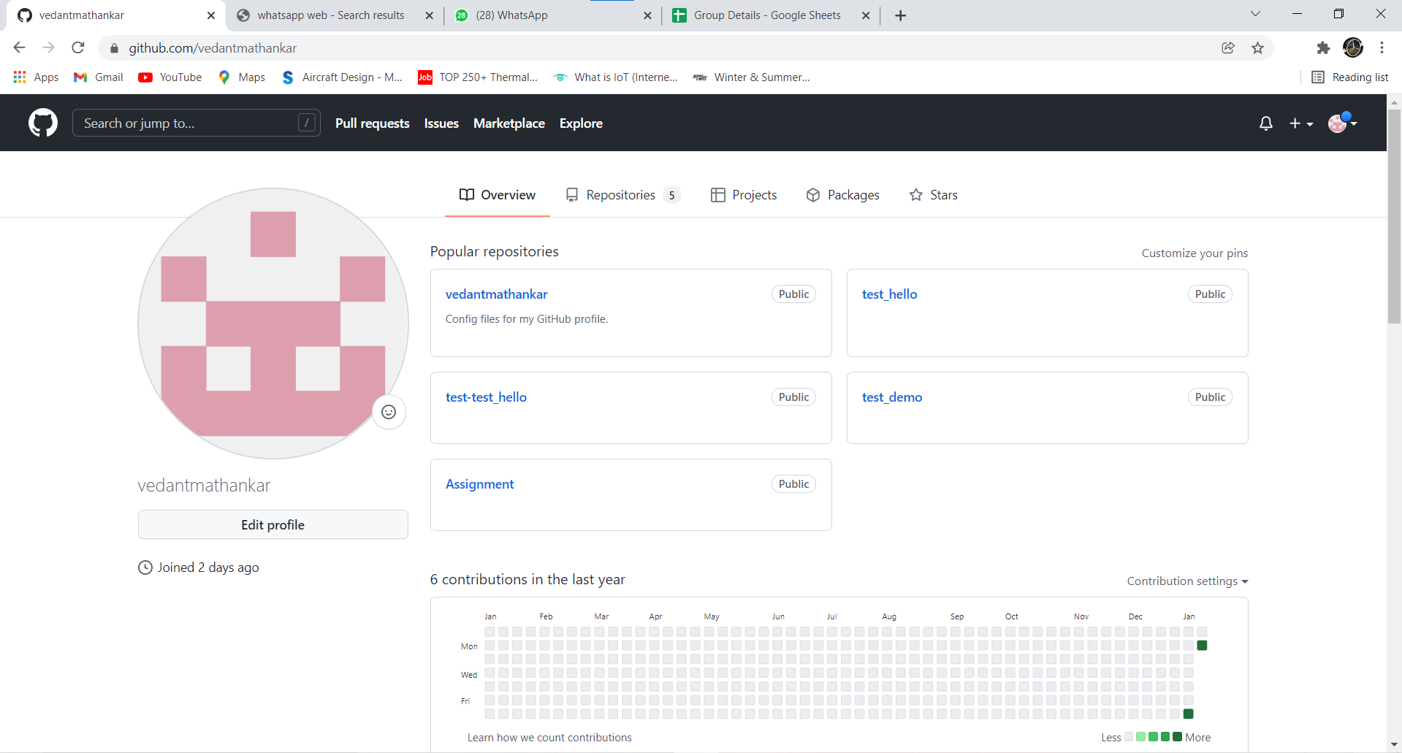

**40. Login on into github account.**



**41. Create new public repository ‘freshersbatch-oct16’.**

Click on New Repository

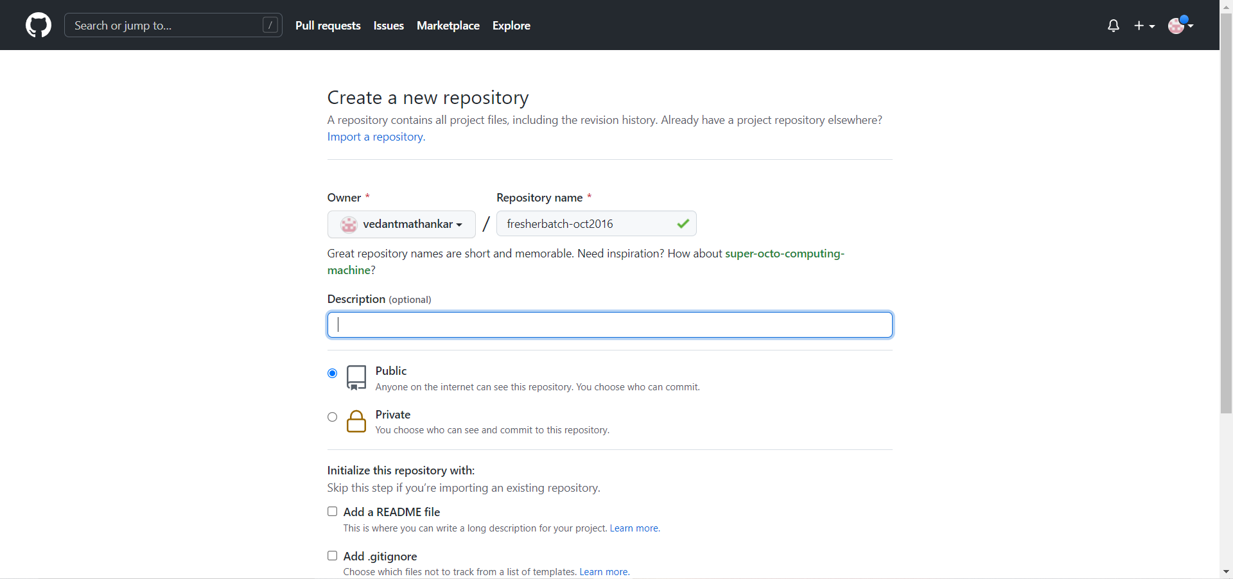

The new repository has been created.

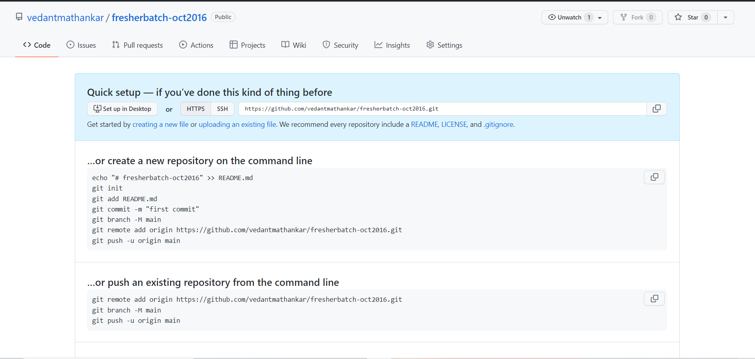

**42. Commit & push any sample file to this repository under ‘Assignments’ directory.**

For Committing:

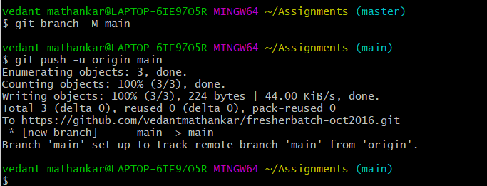

**Push has been made**

